[Type the sender company name]
[TYPE THE SENDER COMPANY ADDRESS]

[Pick the date]

( Sender – Your First and Last Name, Title)
[Type the sender company name]
[Type the sender company address]
Dear (_______________),
As a consumer today, you have many responsibilities. First and foremost, you must do what’s best for you and your family, while protecting yourself financially. Let’s face it, in the current economic environment there is a lot of confusion with regard to financial strategies. Interestingly, many people have no idea what it takes to maintain their standard of living in their retirement years.
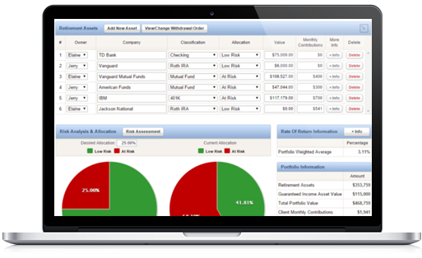

I can provide you a detailed look at your retirement picture. This analysis will help answer the following questions:

Complimentary Risk-analysis Report. a $250 Value

- Can I continue my present standard of living into my retirement years?
- When can I retire without running out of money?
- How can enhancing my Social Security benefit help my specific situation?
- How could my situation change during challenging economic times?
- How would it affect my family if I die prematurely?
- How would it affect my family if I enter a nursing facility?
- What are the possible solutions if my situation changes?

I welcome the opportunity to work together with you to develop a detailed and strategic approach toward your financial future. I will create an easy to understand analysis specific to your situation. I encourage you to take advantage of this complimentary offer.
We would like to take this opportunity to invite you to make an appointment to receive your personalized retirement and insurance analysis. I am looking forward to meeting with you.

Either myself of one of our team members willing be calling to schedule a time that works for us to get together and run a complimentary & personalized ‘Retirement Risk-Analysis’ report that will help answer many of the questions listed above.

Best Regards,
Financial Professional
Title/Firm Name
Phone

